|  |  |
| --- | --- |
| DATE | 12-10-22 |
| TEAM ID | PNT2022TMID21330 |
| PROJECT NAME | Containment-zone-Alerting-App |

**Create UI to interact with application**

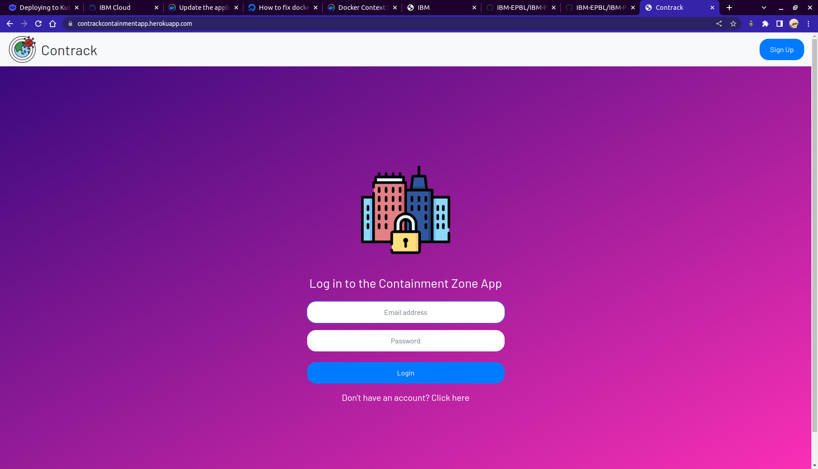**Create IBM DB2 and connect with python**

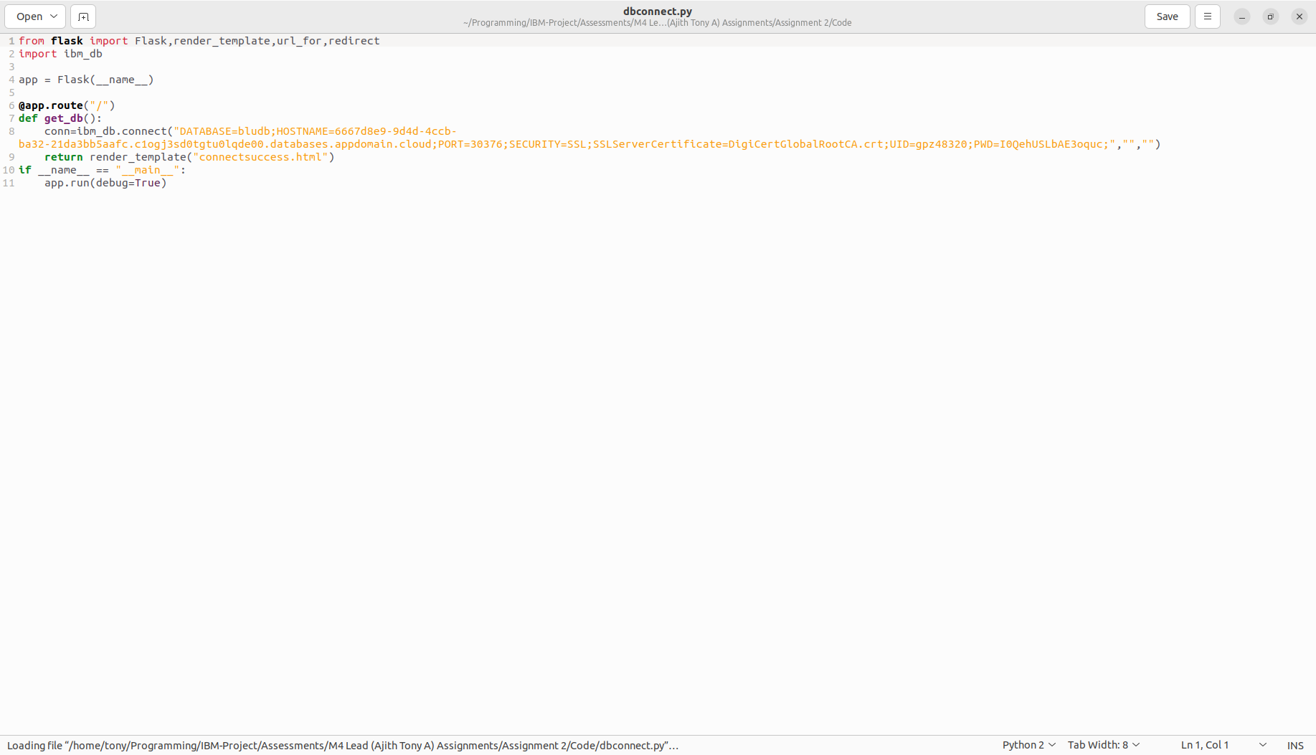**Creating API in Flask**

